**DAILY ONLINE ACTIVITIES SUMMARY**

|  |  |  |  |  |  |  |  |
| --- | --- | --- | --- | --- | --- | --- | --- |
| **Date:** | **06-07-2020** | | | | **Name:** | **B.A.SOHANKUMAR** | |
| **Sem & Sec** | **4th SEM A** | | | | **USN:** | **4AL18CS013** | |
| **Online Test Summary** | | | | | | | |
| **Subject** | | **COMOLEX ANALYSIS, PROBABILITY AND STATISTICAL METHOD** | | | | | |
| **Max. Marks** | | **30** | | **Score** | | **NOT DECLARED** | |
| **Certification Course Summary** | | | | | | | |
| **Course** | **STATISTICAL LEARNING** | | | | | | |
| **Certificate Provider** | | | **GLA** | **Duration** | | | **2.5 HOURS** |
| **Coding Challenges** | | | | | | | |
| **Problem Statement:1:Write a Java program to find the Nth natural number with exactly two bits set .** | | | | | | | |
| **Status: EXECUTED** | | | | | | | |
| **Uploaded the report in Github** | | | | **YES** | | | |
| **If yes Repository name** | | | | **https://github.com/sohannaik5648987/DAILY-REPORTS** | | | |
| **Uploaded the report in slack** | | | | **YES** | | | |

**ONLINE TEST DETAILS:**

Today there was a online test on module1 of ENGINEERING MATHEMATICS .And the duration of the test was 45minutes from 09.30am to 10.15am.It was like written test 3 questions were given to write on A4 paper and to upload in Google classroom.



**CERTIFICATION COURSE DETAILS:**

Course: STATISTICAL LEARNING

Completed modules today are Rules for Probabilty calculation,Bayes' Theorem,Normal Distribution and completed the course.

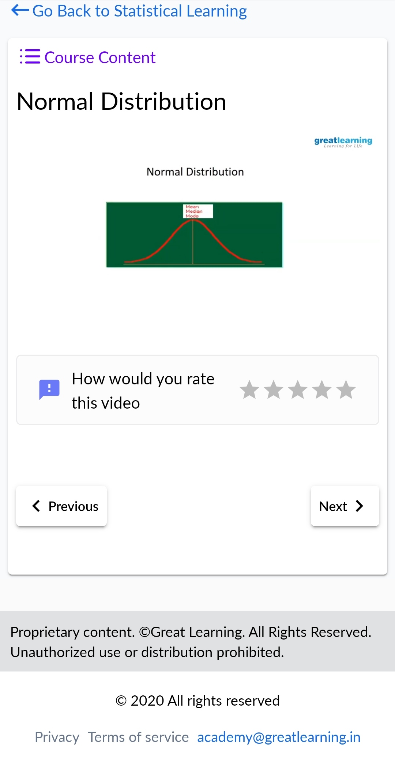 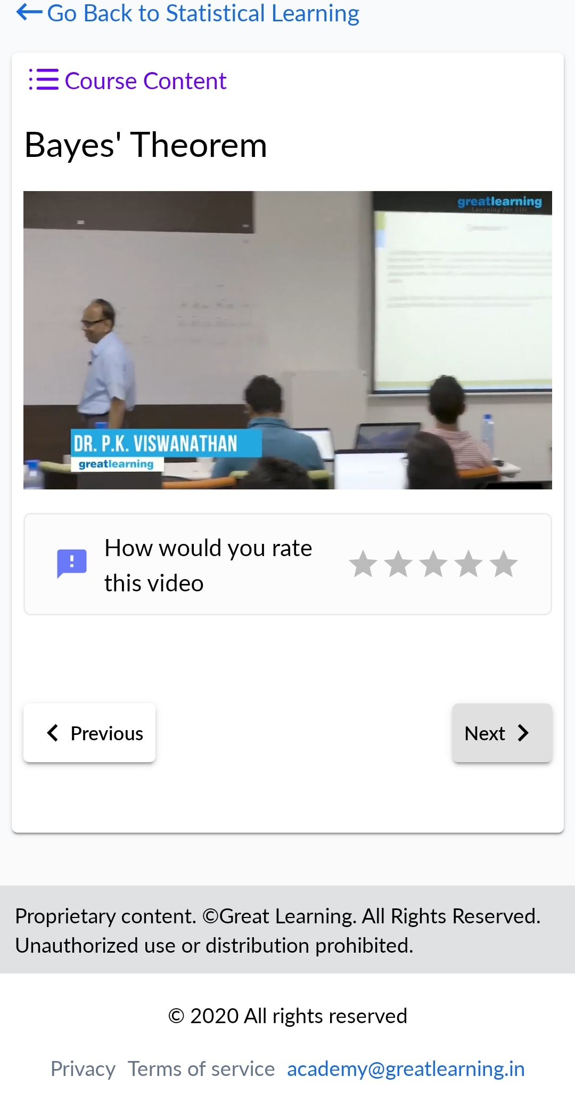

**CODING CHALLENGES DETAILS:**

1.Write a Java program to find the Nth natural number with exactly two bits set.Given an integer N, the task is to find the Nth natural number with exactly two bits set.

Examples:Input: N = 4

Output: 9

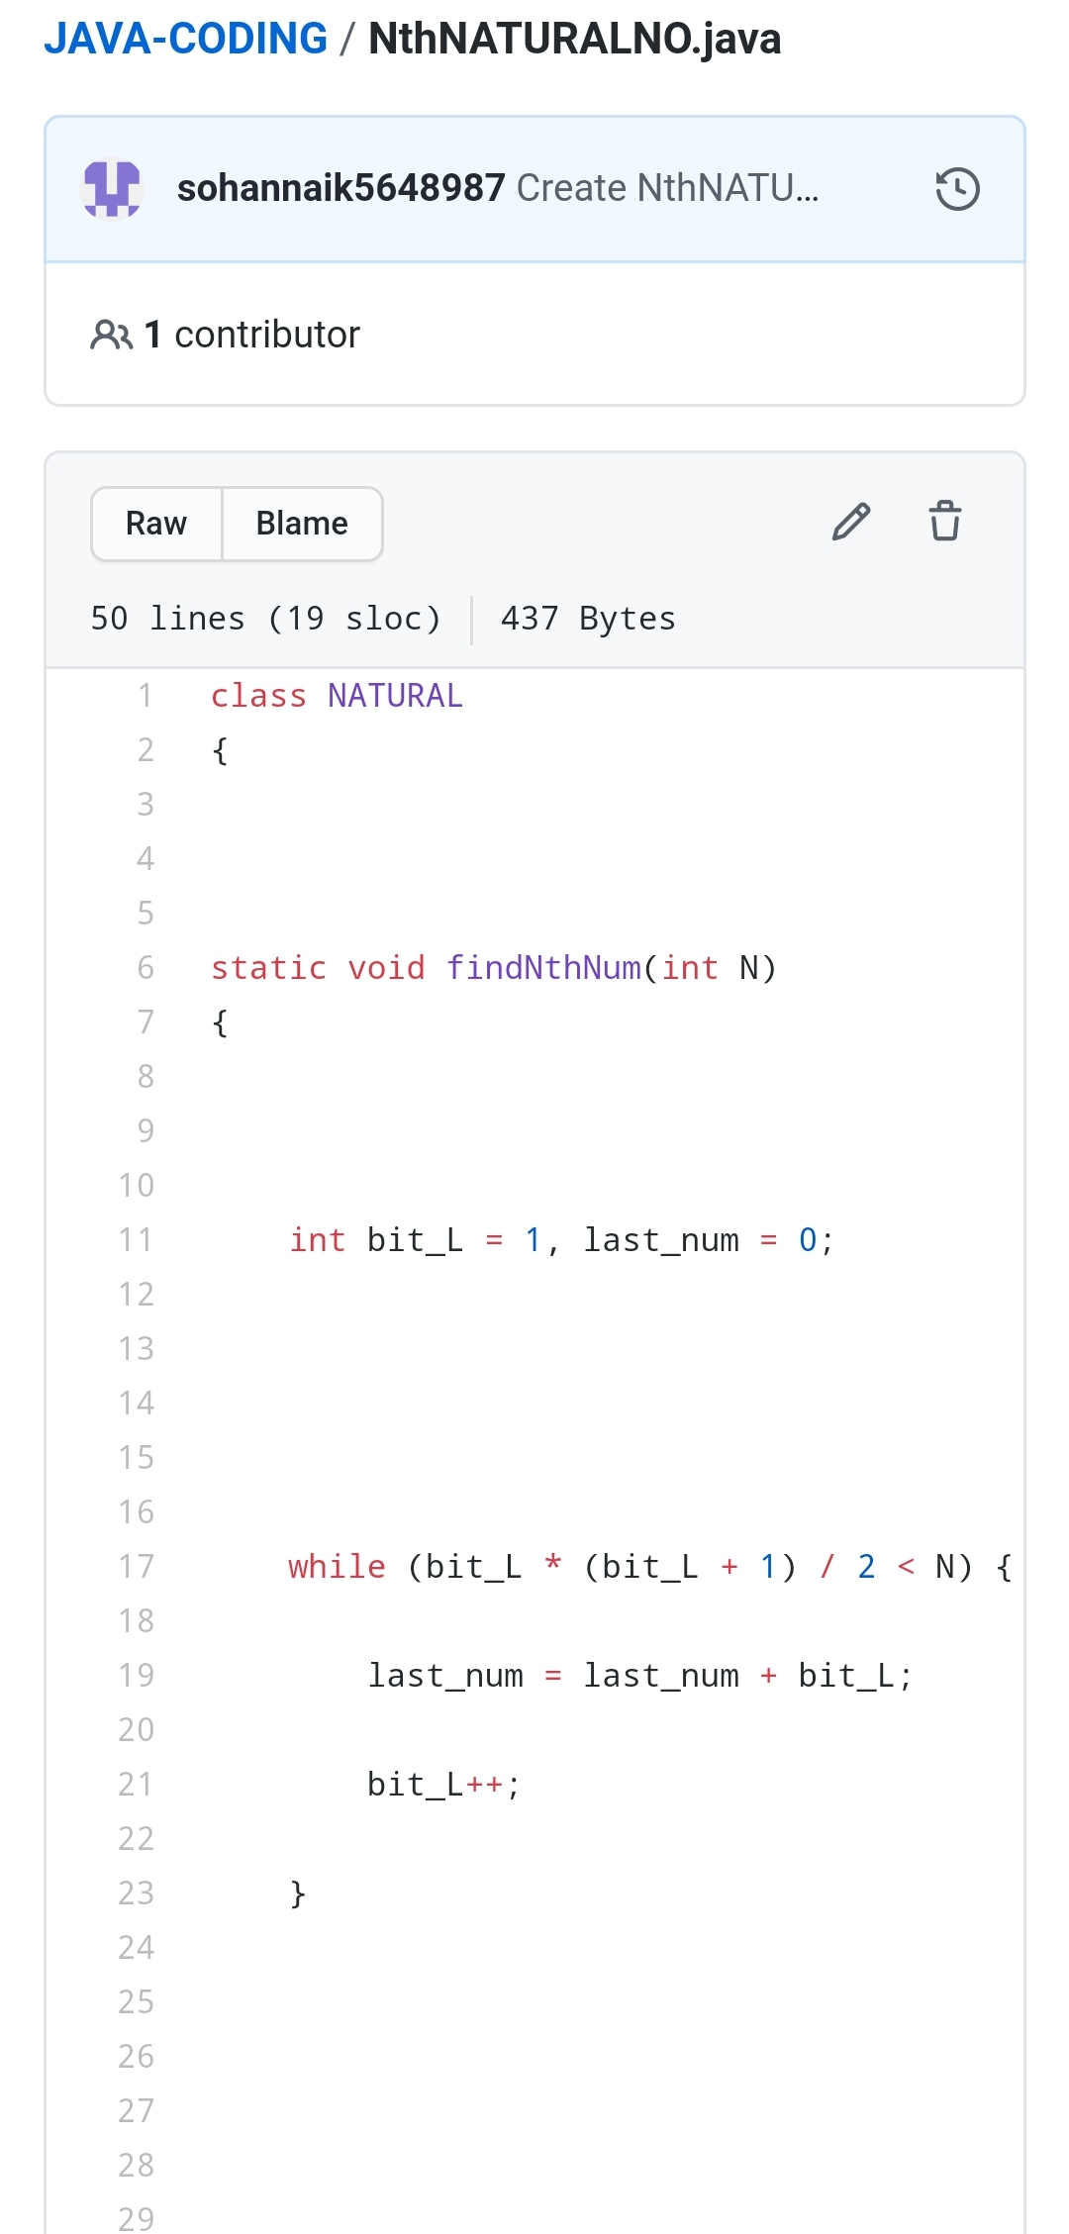

REPOSITORY LINK:https://github.com/sohannaik5648987/JAVA-CODING